Steps to submitting Video sitemap to Google :
- Go to http://www.google.com/webmasters/
- Create a new Google Account. / Sign in to webmaster Tools
- Press “Add a site” site button refer 1.0 & enter your site url.
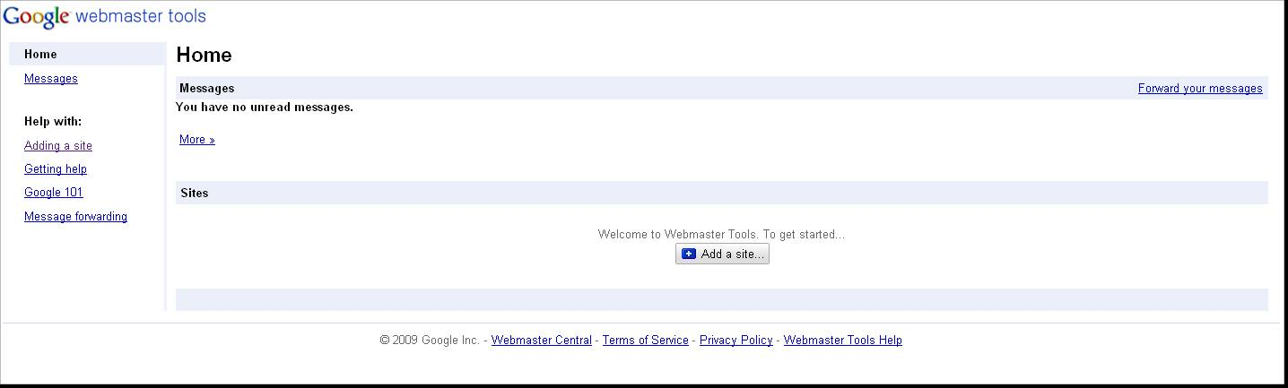
1.0

- After submitting the URL, You need to verify you as the webmaster for that site. Follow the procedures in that page and verify your site. Provide the value of content in Meta data for google sitemap by editing the config file (Edit Configuration) from the admin panel.

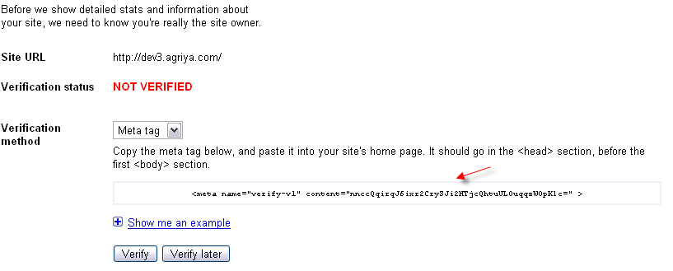

- After Verification, Select “Site configuration & select sitemaps” Refer 2.0
2.0
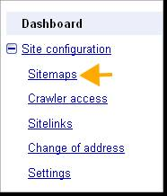

- Press “ Submit a sitemap” . please Refer 3.0 & enter your relative path of videoMapIndex.php . Eg ( if your site path is http:// sample.com/rayzz_videos/ then enter the sitemap url as http:// sample.com/rayzz_videos/ videoMapIndex.php )
3.0
